Final Project

Submitted by: Lital Levy, Oded Rosianski and Shir Bruchim

**1. Project Description**

Our idea is an app that can take a photo of your refrigerator and list what recipes you can make with your ingredients. It will have two main modules: First has a machine - learning mechanism that can transform the photo into a list of ingredients, and the second is a crawler that can run on cooking sites and adds recipes to the database.

**2. Market Requirements Summary**

**2**.**a.** The targeted audiance is the personas described below; almost entirely men who want to become more independent, between the ages of 16-27 and 40+.

**2.b.** Personas:

* A High school student: He needs some food after his school and his parents aren’t there to make it. He also doesn’t have any money, but he can cook.
* A divorced man in his late 40’s: after a long day at work, he wants to explore the cooking world without paying for an expensive course.
* A college student: poor, hungry student who can really use a guiding hand in making food.

**2.c**. There is some competition in this eating field:

* The biggest competition is fast food restaurants. They are making the cheapest food, which is an easy solution to some of the personas described in 4.
* YouTube easy/do-it-yourself cooking guides that are nice to watch and basic to make.
* Eating any instant food.

**2.d.** Many people want to make food with what they bought, and there is currently no way to connect a cooking site online with the current ingredients that you have at home. It takes a lot of time to list what do you currently have and comparing it to the recipe site. Furthermore, many people want to experince good cooking without spending a lot of money, and the app is easy to use.

**3. User Requirements Summary**

**3.a.** User stories

1. **I’m** a high school student that just got back from school. I **want** nutritious food to grow.
2. **I’m** 25, single and currently in my second year of my degree. I have a test coming up and I **want** actual food and not just left overs.
3. **I’m** 44, and my kids are coming in to a visit. I want them to get accustomed to the changes in my life and I **want** them to feel like home.

**3.b.** Mandatory features:

* The groceries recognition algorithm
* The recipe site crawler

Nice to have

* A way to order a missing ingredient if you have everything else at your home

Future work

* A grocery algorithm that takes a picture and tells you which groceries are expired

c+d+e. <https://www.fluidui.com/editor/live/preview/p_X9CQxa5kC8dUWy0luL5eui1iuloTOlJc.1480710058767>

**h. https://docs.google.com/forms/d/e/1FAIpQLScdpDlqoQHvDXlZJ-5esArHkadAPqtiI7UpTzLLh5NbX-iJZw/viewform**

**4. System Requirements Sumary**

**4.a.** Threre are two main features in the architecture, app and crawl: The app takes a picture and sends it to the machine learning module and lists the indgridents found. Once the list is available, the app queries the database to find out which recipes has the best match to the users. The app has a login module for users who wants to keep their list of ingridients and recipies.

The Database fills by continues crawls that adds more fresh recipies everyday.

**4.b. .** System architecture

The diagram is in the following link:

<https://cacoo.com/diagrams/qGmobGfW6xuOCqvl/edit?sampleId=official-1492341>

**4.c.** flows

<https://s28.postimg.org/pv3dm6tf1/Find_Recipe_Sequence_Diagram.png>

<https://s30.postimg.org/fy252u3nl/Crawler_Sequence.png>

<https://s30.postimg.org/yucf0euwx/My_Recipes_Book_Sequence.png>

<https://s30.postimg.org/yvmcttwqp/Recipe_Operations_Sequence.png>

**4.d erd**

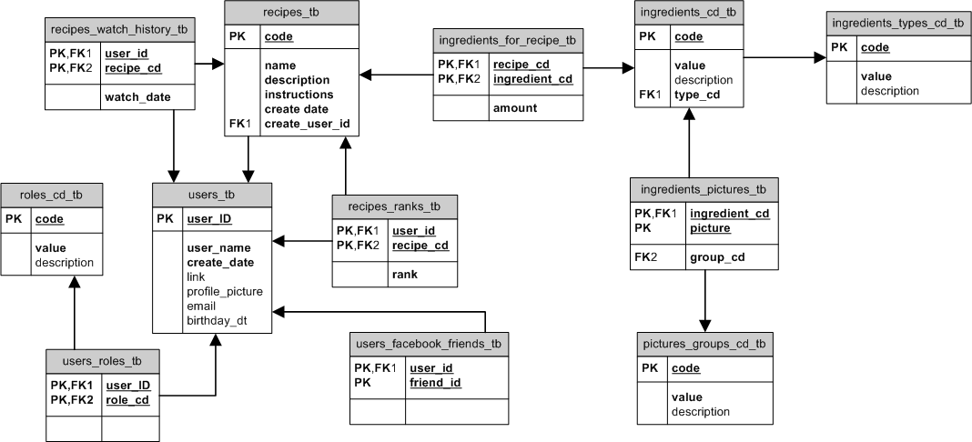

**4.e Technologies**

**Programming Languages:**

JavaScript

Python

JSX

**Developers tools:**

Brackets - an open source code editor for web development

PyCharm - an IDE used for python in order to build the crawler

SciPy - the most useful package for machine learning in Python

**Technologies and Libraries:**

React.js - an open-source JavaScript library for data rendered as HTML

React Native - A framework for building native apps with React

Node.js - an open-source, server-side Javascript technology

Express.js - an open-source library that is a web application framework for Node.js

Scrapy - a popular and powerful Python scraping library - will be used to build the crawler

SciPy (See above) Libraries - scipy numpy, matplotlib, pandas, sklearn

**Storage and Database**

Storage and database will be fully managed with Amazon RDS and Aurora.

The crawler will be run on AWS spot instances (as they fit the requirements).

The photos for the machine learning will be managed in a s3 bucket.

**API’s**

Facebook API integration

BigOven (cooking site) API integration

**4.f Class Diagram**

<https://s24.postimg.org/gf69wlwqd/Super_Chef_Class_Diagram.png>

**5. Testing and QA Summary**

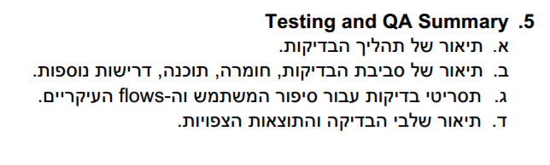

**6. Project Management Methodology and Tools**

We found out that because agile is the best way to communicate and develop because all of us are working at full capacity so we took a weekends sprints, meaning that every weekend we have tasks to finish until sunday. And bebause the moving of tasks is so intuative.

**Github** has a great way of manging code, but the

**Jira – Pros**

* Easy to start with
* Modern and has lots of support online

**Jira – Cons**

* not free
* Does not come with best practices, so every team creates its own methology based of agile .

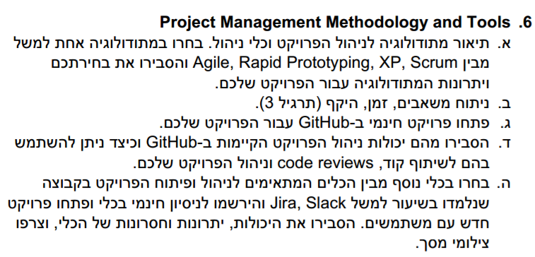

**7. references – צריך עוד**

<https://www.youtube.com/user/makefoodeatfood>

<https://www.youtube.com/watch?v=9P4F-G3FZp8>

(our favorite) <https://www.youtube.com/results?search_query=%D7%97%D7%96%D7%94+%D7%A2%D7%95%D7%A3>